

**CSE Department – Faculty of Engineering - MSA**

**COM265/GSE122/GSE122i Programming 2 – spring 2024/2025**

**Assignment / Lab No ?**

**Instructor: Dr. Ahmed Elanany**

**Deadline DD/MM/YYYY 11:59 PM**

|  |  |  |
| --- | --- | --- |
| **Name:**  **Youssef mohamed**  **..................** | **ID:**  **234833**  **...............** | **Lab Group:**  **i**  **..............** |
| **TA: ENG.Gehad** | **Grade…………………/ 10** | |

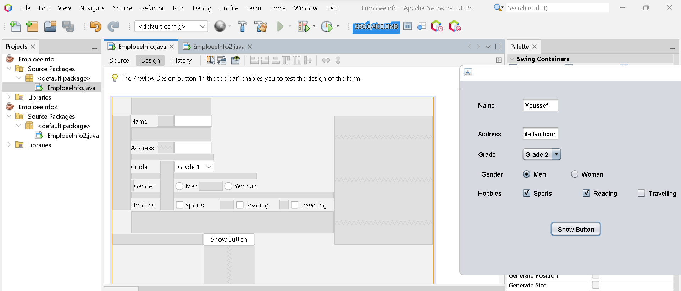

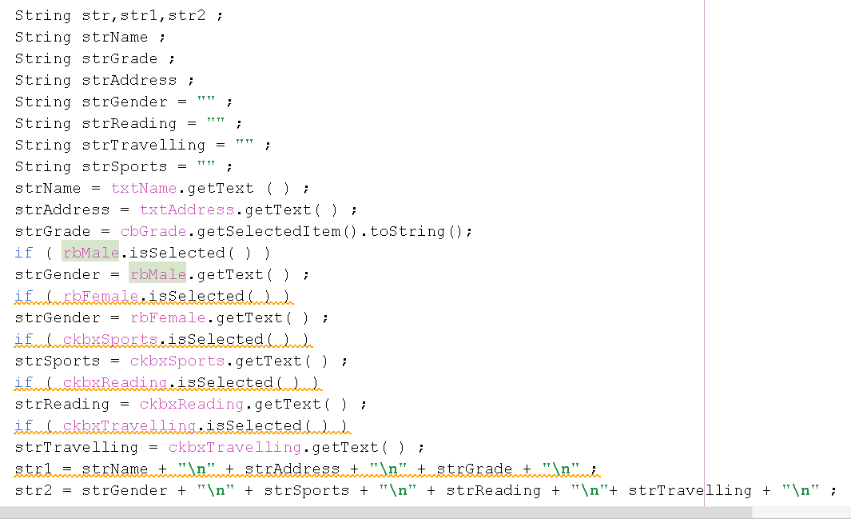

String str,str1,str2 ;

String strName ;

String strGrade ;

String strAddress ;

String strGender = "" ;

String strReading = "" ;

String strTravelling = "" ;

String strSports = "" ;

strName = txtName.getText ( ) ;

strAddress = txtAddress.getText( ) ;

strGrade = cbGrade.getSelectedItem().toString();

if ( rbMale.isSelected( ) )

strGender = rbMale.getText( ) ;

if ( rbFemale.isSelected( ) )

strGender = rbFemale.getText( ) ;

if ( ckbxSports.isSelected( ) )

strSports = ckbxSports.getText( ) ;

if ( ckbxReading.isSelected( ) )

strReading = ckbxReading.getText( ) ;

if ( ckbxTravelling.isSelected( ) )

strTravelling = ckbxTravelling.getText( ) ;

str1 = strName + "\n" + strAddress + "\n" + strGrade + "\n" ;

str2 = strGender + "\n" + strSports + "\n" + strReading + "\n"+ strTravelling + "\n" ;

str = str1+str2 ;

javax.swing.JOptionPane.showMessageDialog ( null, str,"Employee Info",

javax.swing.JOptionPane.INFORMATION_MESSAGE ) ;

}

/**

* @param args the command line arguments

*/

public static void main(String args[]) {

/* Set the Nimbus look and feel */

//<editor-fold defaultstate="collapsed" desc=" Look and feel setting code (optional) ">

/* If Nimbus (introduced in Java SE 6) is not available, stay with the default look and feel.

* For details see http://download.oracle.com/javase/tutorial/uiswing/lookandfeel/plaf.html

*/

try {

for (javax.swing.UIManager.LookAndFeelInfo info : javax.swing.UIManager.getInstalledLookAndFeels()) {

if ("Nimbus".equals(info.getName())) {

javax.swing.UIManager.setLookAndFeel(info.getClassName());

break;

}

}

} catch (ClassNotFoundException ex) {

java.util.logging.Logger.getLogger(EmploeeInfo.class.getName()).log(java.util.logging.Level.SEVERE, null, ex);

} catch (InstantiationException ex) {

java.util.logging.Logger.getLogger(EmploeeInfo.class.getName()).log(java.util.logging.Level.SEVERE, null, ex);

} catch (IllegalAccessException ex) {

java.util.logging.Logger.getLogger(EmploeeInfo.class.getName()).log(java.util.logging.Level.SEVERE, null, ex);

} catch (javax.swing.UnsupportedLookAndFeelException ex) {

java.util.logging.Logger.getLogger(EmploeeInfo.class.getName()).log(java.util.logging.Level.SEVERE, null, ex);

}

//</editor-fold>

/* Create and display the form */

java.awt.EventQueue.invokeLater(new Runnable() {

public void run() {

new EmploeeInfo().setVisible(true);

}

});

}